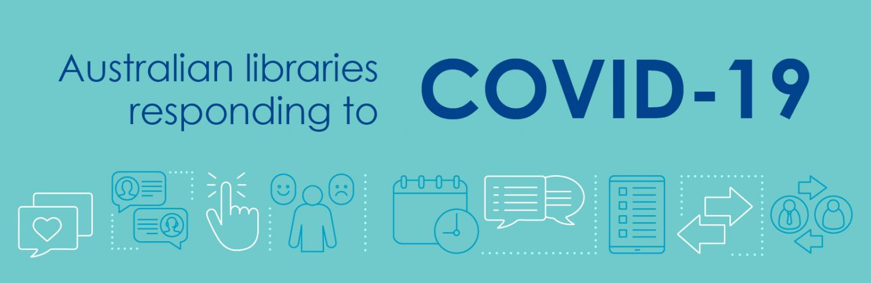

Throughout the COVID-19 pandemic, [Name] library has worked quickly and effectively to respond to the changing situation. This is a summary of what you will have seen.

- Open 24/7

While libraries have had reduced opening hours and been completely closed for periods of time, members have been able to access services online 24/7 throughout the pandemic.

Where branches have been open, there have been limitations on the length of visits and on attendance figures at events and programs, to help keep the community safe.

Mobile library services have been suspended.

- Keeping people informed

We have used our website and social media to let library users know what to expect during the various stages of the pandemic response.

We have provided an online and telephone ‘ask a librarian’ service. Some of our team have gone to other parts of council to help provide information to concerned residents.

- Helping the most vulnerable

We have called all our library users over the age of 70 to offer information and alert them to special services, with conversations in English and other languages where we have a librarian who is multilingual.

We have expanded our home library service to maintain a supply of books for the housebound and elderly. We have made special provisions for homeless people so they can continue to use a library PC during lockdown.
- Moving events online

We have livestreamed and published recordings of virtual storytimes for families at home with very young children.

We have organised author talks, workshops, tech sessions and other online programs to help people be usefully occupied and develop their knowledge and interests.

- Books and much more

We have increased our range of ebooks, emagazines, and other electronic resources such as film streaming by extending our existing subscriptions and introducing new platforms.

We have adopted a click and collect model for book borrowers who prefer print to digital. We have offered mystery book boxes and parcels of books to suit individual tastes for kerbside pick-up. We have partnered with Australia Post and community organisations to arrange home delivery.

We have created craft kits for borrowers and activity packs for children during school holidays.

We have offered a send and collect service for people needing to photocopies and printing.

- Keeping people connected

We have organised online book clubs for juniors, teens and adults; interactive family history sessions; Be Connected webinars for older users, and homework clubs for students.

We have run live chat sessions to connect people with essential services and offer technical and research assistance.

We have turned off WiFi to discourage people from gathering outside the building/boosted WiFi availability around the library for people with their own devices.

- Joining up new members

We have introduced temporary memberships, available online and by phone, to give people immediate access to ebooks and other digital content, without the need to present at a branch with photo ID.

- Putting safety first

We closed book return chutes at the earliest stage of the pandemic and extended loan periods so borrowers did not face overdue fees.

We have introduced social distancing measures, screens, hand sanitising stations, regular cleaning and sanitisation of high traffic areas and quarantining measures for returned books.

We removed shared items such as toys, pens and jigsaw puzzles from the library floor.

Public access PCs have been a particular area of focus, with pre-booking required at times; screens and keyboards cleaned between users, and increased space between terminals.

- Looking after our own team

Some staff have worked from home, others have remained in the library managing the digital services for library users and carrying out behind-the-scenes duties such as collection management and maintenance, weeding, stocktaking and digitisation of local history materials.

We have developed safe working procedures, including contactless book deliveries and collections. We have encouraged personal protection, with the use of disposable gloves and instructions for hand hygiene.

Vulnerable volunteers have been encouraged to stay at home and be safe during the lockdown.

- Other initiatives

We have helped local authors generate some income during this time by signing them up for workshops and events.

Key statistics

Users during lockdown (n)
New members during period (n)
Digital loans (n)
Increase in digital loans (%)
Virtual programs offered (n)
Virtual program participants (n)
Print books distributed (n)
Website visits (n)
Increase in website visits (%)

What people told us

We have had excellent feedback from library users about how we have handled the situation.

“ebooks were desperately important during isolation.”

“I have two teenaged kids and they loved the homework help available from the library.”

“Good to ‘meet’ interesting people like artists and authors. It has kept me sane.”

This is a snapshot of the COVID-19 related activity carried out by [Name] library from March to [month] 2020. If you have feedback or ideas about what more the library can do to support our community, please contact us via [web address].

